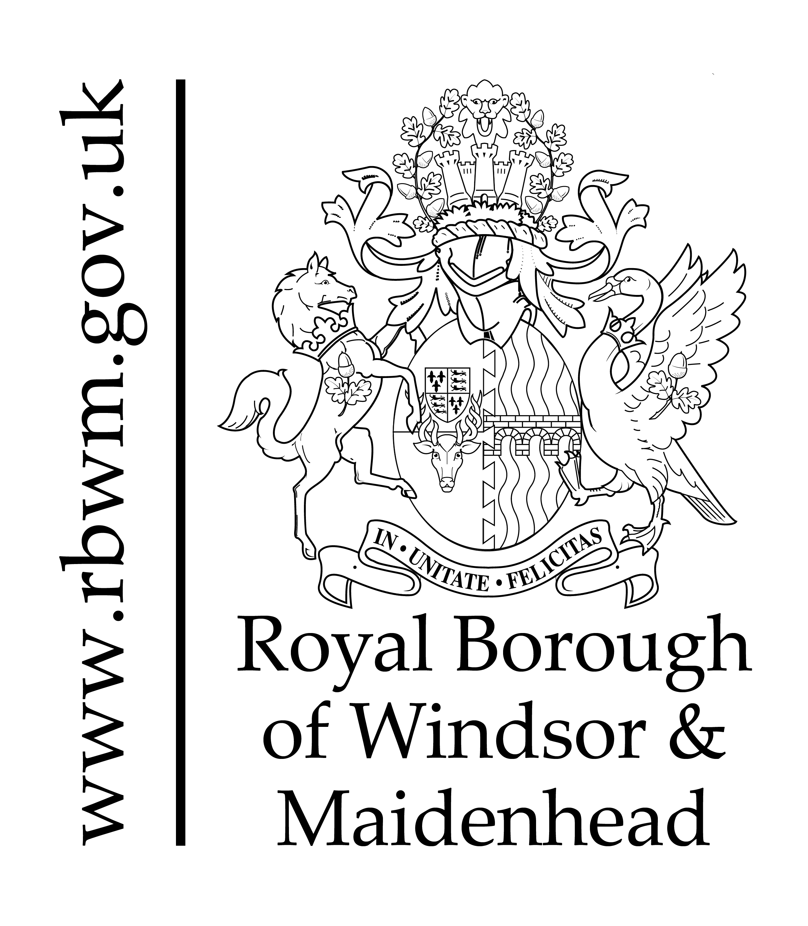

Ref:

(For official use only)

Royal Borough of Windsor & Maidenhead

Proposed Designation of Maidenhead Neighbourhood Area and Maidenhead Neighbourhood Forum

Public Consultation period from Tuesday 25 October until 11:59pm on Tuesday 6 December - Completed forms must be received at our offices by 11:59pm on Tuesday 6 December 2022.

We would encourage you to respond online at:
https://consult.rbwm.gov.uk/kse

Further information about the consultation can be found at:
https://www.rbwm.gov.uk/home/planning/planning-policy/emerging-plans-and-policies/neighbourhood-plans/consultations-neighbourhood-plans

Alternatively, you may email completed forms to:planning.consultation@rbwm.gov.uk or send them by post to: Planning Policy, Royal Borough of Windsor & Maidenhead, Town Hall, St Ives Road, Maidenhead, SL6 1RF.

  - Part A – Contact details
Please also note that all representations received will be available for the public to view and cannot be treated as confidential. Data will be processed and held in accordance with the Data Protection Act 2018 and the General Data Protection Regulations 2018. The Council’s data protection policy can be found at:
Data protection | Royal Borough of Windsor and Maidenhead (rbwm.gov.uk)

Description | - Personal Details | - Agent details (if applicable)
Title
First Name
Job title (where relevant)
Address Line 1
Address Line 2
Address Line 3
Address Line 4
Postcode
Telephone number
Email address (where relevant)

  - Part B – Your comments

Name or Organisation:

3. | Please set out here your comments on the proposed Maidenhead Neighbourhood Area

4. | Please set out here your comments here on the proposed Maidenhead Neighbourhood Forum

Please note that your representation should cover precisely all the information necessary to support your representations, as there will not normally be a subsequent opportunity to make further representations. All representations will be held by the Council in accordance with the Data Protection Act. Your name, organisation (if relevant) and representations may be made available to the public, in council committee papers and as otherwise considered appropriate by us. Your personal data i.e. postal addresses, emails and telephone numbers will not be shared with the public.

Date submitted:

  - Privacy notice : Planning Policy : Consultations and Call for Sites
Available from: https://www.rbwm.gov.uk/home/council-and-democracy/strategies-and-policies/data-protection/privacy-notice-planning-policy-consultations-and-call-sites

Who we are
Planning Policy
Royal Borough of Windsor and Maidenhead
Town Hall, St Ives Road
Maidenhead SL6 1RF

Lawful basis for processing the information
The Town & Country Planning Act 1990
Planning and Compulsory Purchase Act 2004
Planning Act 2008 (as amended by Part 6 of the Localism Act 2011)
Self-build and Custom Housebuilding Act 2015, as amended
Housing and Planning Act 2016
Neighbourhood Planning Act 2017
The Town and Country Planning (Local Planning)(England) Regulations 2012, as amended
Neighbourhood Planning (General) Regulations 2012, as amended
Self-build and Custom Housebuilding Regulations 2016
Self-build and Custom Housebuilding (Time for Compliance and Fees) Regulations 2016
General Data Protection Regulation - Article 6(1)(e) processing is necessary for the performance of a task carried out in the public interest or in the exercise of official authority vested in the controller.

How we collect information
Personal data is supplied by service users in representation to call for sites and consultations either by post, email, telephone call or electronically via the Council’s website or the Planning portal.

Categories of information collected
As part of development plan making, consultations, neighbourhood planning and creation of registers we may collect names, addresses, organisation name, position held, telephone numbers, email addresses, signature and information on financial details, agent details, land/property ownership, consultation representation contents, age, gender, ethnicity, disability, number of dependants and nationality of:
Land owners and developers wishing to promote sites.
People who have supplied representations and made representations on draft development plan documents (DPD’s) as they move through the plan making process.
People who have notified us that they wish to be included on a consultation database for plan-making and preparation of Supplementary Planning Documents (SPD’s).
People who have notified us that they wish to be included on a consultation database for Neighbourhood Plan consultations.
People who have notified us that they wish to be included on the Self-build Register.
In some circumstances we will also collect details of directors and company secretaries of businesses being investigated and land registry documents.
We are provided with names, addresses, telephone numbers, email addresses of potential house purchasers from their acting Solicitor and anyone requesting site history, copies of planning documents or general planning advice.

How we use the information provided
The information gathered is used to:
Prepare a regular assessment of the Council’s supply of potential future development sites including the Housing and Employment Land Availability Assessment (HELAA) and Traveller Land Availability Assessment (TLAA).
Maintain a database of people that we contact and consult with during various stages of the Neighbourhood Plan and DPD, plan making process.
Maintain a database of people that we contact and consult with during the preparation of SPD’s.
Maintain a register of people who have asked to be on the Self-build Register. The register assists the Council understand the level of interest in the Borough for self and custom build plots.
Personal data collected may be recorded on Uniform, Objective, the Council’s IT network and QGIS. Documents are held in the Council’s Document Management System, the Council’s IT network and on Objective. The Self Build Register data and personal information collected for the HELAA is not made available to the public.
Any personal data recorded on public documents associated with the call for sites will be removed prior to publication.
Contact details of people on the consultation database are occasionally shared with bodies associated with examining plans to facilitate their professional and statutory roles.

Who has access to the systems that store the information about you
Officers within the planning department have access to the data collected. Members of the public have access to personal data on enforcement notices and submitted appeals.

Who we may share your information with
Personal data may be shared within the Planning service, other Council departments and the Planning Inspectorate, Plan Examiners & Programme Officers. Where applicable, names of representors will be viewable on the Council’s consultation portal - http://consult.rbwm.gov.uk/portal.

How long we store your information
Information is kept as a permanent record.
Does your service utilise automated decision making? - No

